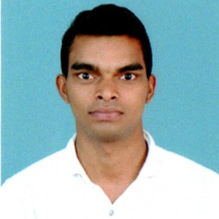

7639054690

[mallikarjuna](mailto:mallikarjunav747@gmail.com)[v747@gmail.com](mailto:v747@gmail.com)

# CAREER OBJECTIVE:

To work in a creative, innovative and challenging environment and to achieve organization’s goals in the most efficient manner by applying my skills and abilities and there by growing with the organization.

# ACADEMIC QUALIFICATION:

|  |  |  |  |  |
| --- | --- | --- | --- | --- |
| **Course** | **Institution** | **Board/**  **University** | **Year of**  **Completion** | **Percentage** |
| B. Tech (MECH) | S. V. College of Engineering, Tirupathi | JNTU  Ananthapur | 2019 | 70.00 |
| Intermediate | Umamaheswara Junior College, Ongole | BIE | 2015 | 89.6 |
| Secondary School | Vikas High School,Kandukur | BSE | 2013 | 90 |

**TECHNICAL SKILLS:**

* Programming Languages : Core Java ,Spring MVC,JDBC
* DevopsTools : Git,Jenkins,Docker,Ansible,Puppet
* DataBases : My Sql 5.5
* Operating Systems : Windows-10,Linux(Ubuntu-20.0)

# WORKSHOPS ATTENDED:

* Attended a “**WORKSHOP TECHNOLOGY IN INTERNAL COMBUSTION ENGINE”** from S.V University in Tirupathi.
* Attended a ” **Auto CADD Software Technology”** from SV College of Engineering.

# SEMINARS/ CONFERENCES ATTENDED:

* Attended a seminar on “**Entrepreneurship**” at SV College of Engineering Tirupathi.
* Attended a seminar on “**Thermal Engineering**” at SV College of Engineering Tirupathi.

# PROJECT REPORT:

# “DESIGN AND FABRICATION OF AUTOMATIC TYRE INFLATION SYSTEM”

**INTERNSHIP:**

* Attended a internship on **“Carriage Repair Shop”** at South Central Railway Tirupathi.

**Proof Of Concepts:**

**1)Spring MVC Example for User Registration and Login:**

**Technology Used:**

Spring Framework(Core, MVC & JDBC), Java1.8, Maven3.3.9,Eclipse IDE and My Sql 5.5.

**Description:**

The module User Registration and Login is a web frame work. Which makes easy way to login

the webpage and access the data from database.

# PROFILE SUMMARY:

* + Always willing to innovative the new things which can improve the existing technology.
  + Eager to learn new methodologies.
  + Have Good team leader qualities.

# STRENGTHS:

* + Positive Thinking
  + Flexible in any Environment.

# EXTRA CURRICULAR ACTIVITIES:

* + Coordinator of Anti Ragging in SV College of Engineering.

# PERSONAL DETAILS:

* + Father’s Name : Mr. V. Malyadri
  + Date of Birth : 17-12-1997
  + Languages Known : English, and Telugu
  + Hobbies : Listening Music

# DECLARATION:

I hereby declare that the above mentioned information is correct up to my knowledge and I bare the responsibility for the correctness of the above mentioned particulars.

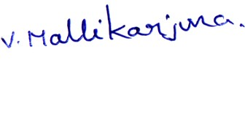

# ( Veesam Mallikarjuna )